Task-2 :Run Hello World Docker Image Locally.

Step1:

Docker pull command to download hello-world image from docker hub.

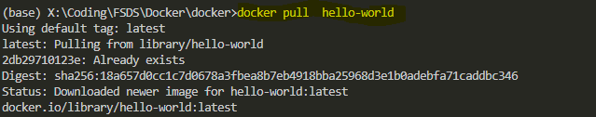

Step2- Run the hello-world image locally.

